**Assignment #8**

Daniel S Prusinski

**Introduction:**

Principal component analysis is a helpful non-parametric method for discovering relationships from many different variables in a data set. Factor analysis is a method for grouping variables together and identifies the latent dimensions in the variables. For this assignment, both techniques will be applied to a dataset to explore and extract information from the original data.

**Part 1: An initial Correlation Analysis:**

| **Pearson Correlation Coefficients, N = 1000 Prob > |r| under H0: Rho=0** | | | |
| --- | --- | --- | --- |
|  | **x1_1** | **x1_2** | **x1_3** |
| **z1** | 0.79023 <.0001 | 0.27726 <.0001 | 0.31560 <.0001 |
|  | **x2_1** | **x2_2** | **x2_3** |
| **z2** | 0.31942 <.0001 | 0.22605 <.0001 | 0.19271 <.0001 |
|  | **x3_1** | **x3_2** | **x3_3** |
| **z3** | 0.72089 <.0001 | 0.20415 <.0001 | 0.52932 <.0001 |
|  | **x4_1** | **x4_2** | **x4_3** |
| **z4** | 0.09325 0.0032 | 0.46617 <.0001 | 0.55083 <.0001 |
|  | **x5_1** | **x5_2** | **x5_3** |
| **z5** | 0.77975 <.0001 | 0.18591 <.0001 | 0.52800 <.0001 |

The Z variables have the strongest correlation with the X variables from the first subset. Three of the five first subset variables have strong correlation coefficients. Preliminarily it looks like there are some strong correlation coefficients, but more analysis would need to be conducted to validate the linearity assumptions. Of all the variables, Z4 has the weakest correlation coefficient with the X variables. Z1, Z3, Z5 all have strong correlation coefficients with the firs variable.

**Part 2: Principal Components:**

Standardizing the data before performing any type of “components” or “factor” analysis is important as it allows the variables to have an equal influence despite individual units. This does not change the ratios between different pairs of objects; rather it makes the overall interpretation more distinct (web.psych.unimelb.edu).

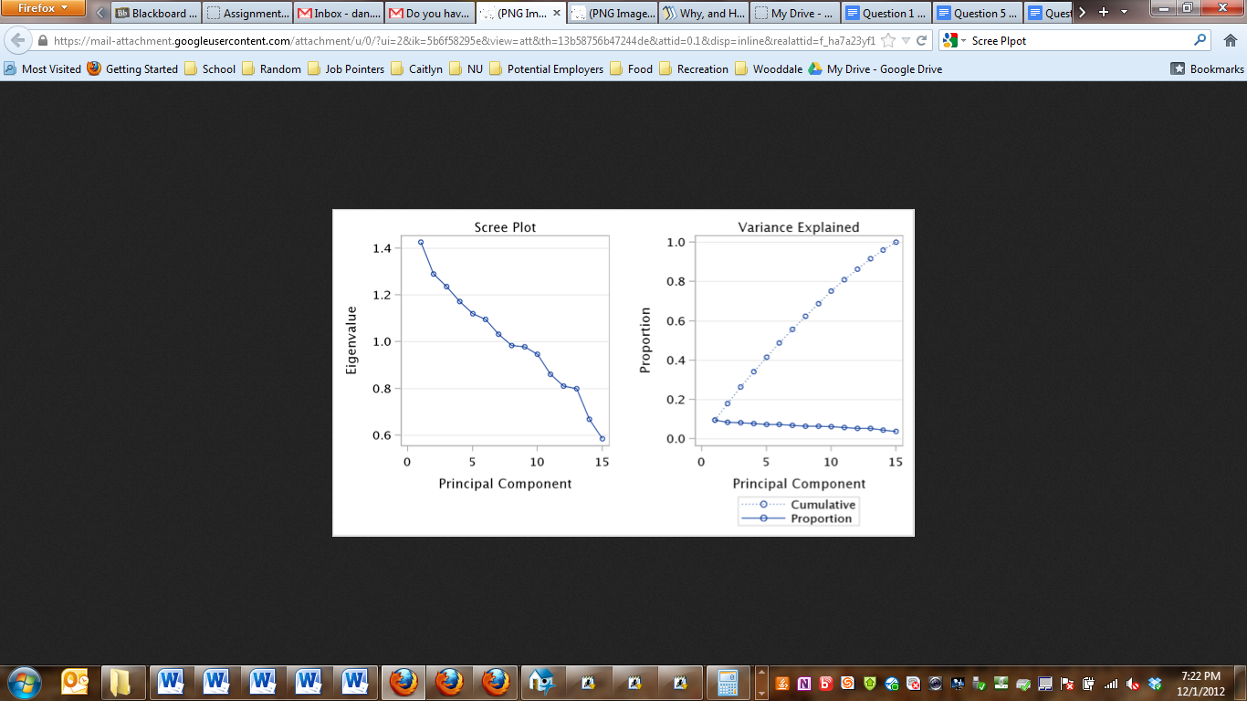

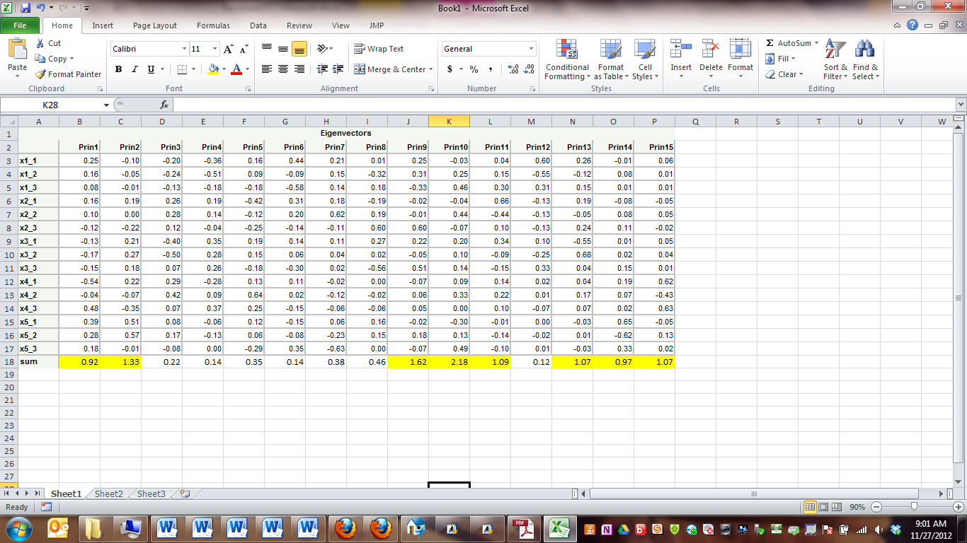

The principal components that have eigenvectors that explain the greatest variation in the predictor variables are: principal components 1, 2, 9, 10, 11, 13, 14, 15. I highlighted these values above, and I use these values because of the variation they explain. These components account for 85% of the variation throughout all the components. The correlation structure between the components is such that the last six of the seven components have strong correlations, while the first two components have relatively strong correlation as well.

| **Eigenvalues of the Correlation Matrix** | | | | |
| --- | --- | --- | --- | --- |
|  | **Eigenvalue** | **Difference** | **Proportion** | **Cumulative** |
| **1** | 1.42537946 | 0.13663847 | 0.0950 | 0.0950 |
| **2** | 1.28874099 | 0.05409204 | 0.0859 | 0.1809 |
| **3** | 1.23464895 | 0.06364847 | 0.0823 | 0.2633 |
| **4** | 1.17100048 | 0.05040574 | 0.0781 | 0.3413 |
| **5** | 1.12059474 | 0.02567880 | 0.0747 | 0.4160 |
| **6** | 1.09491595 | 0.06220971 | 0.0730 | 0.4890 |
| **7** | 1.03270623 | 0.04957906 | 0.0688 | 0.5579 |
| **8** | 0.98312718 | 0.00510939 | 0.0655 | 0.6234 |
| **9** | 0.97801778 | 0.03086678 | 0.0652 | 0.6886 |
| **10** | 0.94715100 | 0.08629638 | 0.0631 | 0.7518 |
| **11** | 0.86085462 | 0.04956912 | 0.0574 | 0.8091 |
| **12** | 0.81128550 | 0.01267730 | 0.0541 | 0.8632 |
| **13** | 0.79860821 | 0.12994927 | 0.0532 | 0.9165 |
| **14** | 0.66865894 | 0.08434898 | 0.0446 | 0.9610 |
| **15** | 0.58430996 |  | 0.0390 | 1.0000 |

**Part 3: Factor Analysis:**

The method of factor analysis performed in Example 1 is Maximum Likelihood Factor Analysis. The error message generated in the SAS log states that communality is greater than 1, thus this method cannot be used. The SAS user guide stipulates that the ML method cannot be used with a single correlation matrix, which is why another method needs to be used.

| **Preliminary Eigenvalues: Total = 3.061678 Average = 0.20411187** | | | | |
| --- | --- | --- | --- | --- |
|  | **Eigenvalue** | **Difference** | **Proportion** | **Cumulative** |
| **1** | 0.97613665 | 0.21857792 | 0.3188 | 0.3188 |
| **2** | 0.75755873 | 0.25536063 | 0.2474 | 0.5663 |
| **3** | 0.50219811 | 0.11031692 | 0.1640 | 0.7303 |
| **4** | 0.39188118 | 0.09560732 | 0.1280 | 0.8583 |
| **5** | 0.29627386 | 0.07995004 | 0.0968 | 0.9550 |
| **6** | 0.21632382 | 0.05336783 | 0.0707 | 1.0257 |
| **7** | 0.16295599 | 0.05028800 | 0.0532 | 1.0789 |
| **8** | 0.11266800 | 0.01639943 | 0.0368 | 1.1157 |
| **9** | 0.09626857 | 0.04203941 | 0.0314 | 1.1472 |
| **10** | 0.05422916 | 0.06995174 | 0.0177 | 1.1649 |
| **11** | -.01572258 | 0.03991642 | -0.0051 | 1.1597 |
| **12** | -.05563900 | 0.03190769 | -0.0182 | 1.1416 |
| **13** | -.08754669 | 0.05246228 | -0.0286 | 1.1130 |
| **14** | -.14000896 | 0.06588989 | -0.0457 | 1.0673 |
| **15** | -.20589885 |  | -0.0673 | 1.0000 |

| **Significance Tests Based on 1000 Observations** | | | |
| --- | --- | --- | --- |
| **Test** | **DF** | **Chi-Square** | **Pr > ChiSq** |
| **H0: No common factors** | 105 | 400.9678 | <.0001 |
| **HA: At least one common factor** |  |  |  |

|  |  |
| --- | --- |
| **Chi-Square without Bartlett's Correction** | 403.32283 |
| **Akaike's Information Criterion** | 193.32283 |
| **Schwarz's Bayesian Criterion** | -321.99148 |
| **Tucker and Lewis's Reliability Coefficient** | 0.00000 |

**Part 3: Example 2:**

The method of factor analysis performed in Example 2 is the Unweighted Least Squares Method with Heywood approach which allows communality to exceed 1 and the iteration process to continue. The error message generated means there are too many factors in the set for the process to work and a unique solution to be calculated. It is my opinion that we have too many factors for this calculation to return without any errors. If we reduce the factors in the problem then perhaps we will not have SAS output that has errors.

| **Eigenvalues of the Reduced Correlation Matrix: Total = 5.80062438 Average = 0.38670829** | | | | |
| --- | --- | --- | --- | --- |
|  | **Eigenvalue** | **Difference** | **Proportion** | **Cumulative** |
| **1** | 1.12128560 | 0.11790914 | 0.1933 | 0.1933 |
| **2** | 1.00337646 | 0.16916826 | 0.1730 | 0.3663 |
| **3** | 0.83420819 | 0.06165979 | 0.1438 | 0.5101 |
| **4** | 0.77254841 | 0.07390229 | 0.1332 | 0.6433 |
| **5** | 0.69864612 | 0.18714614 | 0.1204 | 0.7637 |
| **6** | 0.51149998 | 0.14287112 | 0.0882 | 0.8519 |
| **7** | 0.36862886 | 0.12144146 | 0.0635 | 0.9155 |
| **8** | 0.24718740 | 0.10372523 | 0.0426 | 0.9581 |
| **9** | 0.14346217 | 0.04367811 | 0.0247 | 0.9828 |
| **10** | 0.09978406 | 0.09796679 | 0.0172 | 1.0000 |
| **11** | 0.00181727 | 0.00141753 | 0.0003 | 1.0003 |
| **12** | 0.00039974 | 0.00035794 | 0.0001 | 1.0004 |
| **13** | 0.00004180 | 0.00076161 | 0.0000 | 1.0004 |
| **14** | -.00071981 | 0.00082205 | -0.0001 | 1.0003 |
| **15** | -.00154186 |  | -0.0003 | 1.0000 |

| **Standardized Scoring Coefficients** | | | | | | | | | | |
| --- | --- | --- | --- | --- | --- | --- | --- | --- | --- | --- |
|  | **Factor1** | **Factor2** | **Factor3** | **Factor4** | **Factor5** | **Factor6** | **Factor7** | **Factor8** | **Factor9** | **Factor10** |
| **x1_1** | 0.04729 | -0.02285 | 0.13403 | -0.00592 | -0.08310 | 0.61290 | 0.07241 | 0.12276 | -0.00961 | 0.04621 |
| **x1_2** | 0.01639 | -0.01132 | 0.02279 | -0.00083 | -0.02547 | 0.12943 | -0.00658 | -0.18049 | 0.16229 | 0.03607 |
| **x1_3** | 0.00632 | -0.00791 | 0.00438 | 0.01158 | -0.02086 | -0.01463 | -0.02375 | -0.16504 | 0.15683 | -0.14697 |
| **x2_1** | 0.01449 | 0.00415 | 0.01885 | 0.00554 | 0.01942 | -0.03664 | -0.11101 | 0.25769 | 0.07587 | 0.03394 |
| **x2_2** | 0.01335 | 0.00695 | 0.01208 | 0.01471 | -0.01147 | -0.00273 | -0.09001 | 0.21632 | 0.10623 | -0.17522 |
| **x2_3** | -0.18283 | -0.03243 | -0.07328 | 0.83117 | 0.18170 | 0.05674 | 0.11532 | 0.01340 | 0.00962 | 0.00071 |
| **x3_1** | -0.00234 | -0.01771 | -0.02882 | -0.03516 | 0.00878 | -0.02976 | 0.29760 | 0.09751 | 0.02624 | -0.03900 |
| **x3_2** | -0.00466 | -0.02705 | -0.04722 | -0.06570 | 0.01708 | -0.04727 | 0.37177 | 0.03236 | 0.02727 | -0.01827 |
| **x3_3** | 0.00412 | -0.00083 | -0.03549 | -0.00388 | 0.02157 | -0.08865 | 0.01917 | 0.05443 | 0.16193 | 0.18672 |
| **x4_1** | -0.04867 | -0.00406 | -0.17331 | -0.05123 | 0.15978 | 0.02355 | -0.08885 | 0.00158 | -0.11854 | 0.05936 |
| **x4_2** | -0.05423 | 0.92624 | 0.01029 | -0.02638 | 0.22472 | 0.08374 | 0.08759 | -0.02329 | 0.06587 | -0.04041 |
| **x4_3** | 0.09119 | 0.10247 | 0.40710 | 0.16441 | -0.43321 | -0.19544 | 0.03550 | 0.00638 | -0.07354 | 0.08239 |
| **x5_1** | 0.92964 | 0.04143 | -0.19050 | 0.21910 | 0.18622 | -0.01890 | 0.03584 | -0.04673 | -0.12269 | -0.02624 |
| **x5_2** | 0.01120 | -0.00651 | 0.00387 | -0.00629 | 0.04700 | 0.00015 | -0.01823 | 0.01645 | 0.17261 | 0.06887 |
| **x5_3** | 0.04284 | -0.11648 | 0.59837 | -0.06147 | 0.59785 | -0.06930 | 0.03067 | -0.04320 | -0.03060 | -0.01896 |

**Part 4: Factor Analysis:**

What is wrong with this factor analysis is we only used 5 of the 15 factors. We are not generating a complete picture of all the factors we are supposed to be analyzing. By changing the nfactors to 5, SAS was able to compute without any errors. The VARIMAX rotational method is an orthogonal method that maximizes the sum of variances for the factor matrix, and simplifies the columns of the factor matrix. This method reduces the number of variables and produces uncorrelated variables as well.

| **Factor Pattern** | | | | | |
| --- | --- | --- | --- | --- | --- |
|  | **Factor1** | **Factor2** | **Factor3** | **Factor4** | **Factor5** |
| **x1_1** | -0.03642 | 0.12602 | 0.00315 | -0.02541 | 0.30710 |
| **x1_2** | -0.04783 | 0.06825 | 0.01944 | -0.04121 | 0.34917 |
| **x1_3** | -0.05750 | 0.03644 | 0.00990 | -0.02195 | 0.03695 |
| **x2_1** | -0.03481 | 0.05830 | 0.09203 | -0.08623 | -0.15146 |
| **x2_2** | 0.02957 | 0.04987 | 0.01036 | -0.05946 | -0.08302 |
| **x2_3** | -0.00344 | -0.04455 | -0.10032 | -0.08189 | -0.04925 |
| **x3_1** | -0.02657 | -0.06177 | 0.04647 | 0.26562 | -0.01603 |
| **x3_2** | -0.08712 | -0.14773 | 0.12392 | 0.59806 | 0.02647 |
| **x3_3** | -0.00118 | -0.06692 | 0.03996 | 0.03740 | -0.14676 |
| **x4_1** | 0.23260 | -0.64413 | 0.13520 | -0.16702 | 0.03246 |
| **x4_2** | 0.98892 | 0.11508 | -0.00312 | 0.09017 | 0.02879 |
| **x4_3** | 0.08273 | 0.46049 | -0.15986 | 0.04359 | -0.08355 |
| **x5_1** | -0.03098 | 0.21404 | 0.44628 | -0.03638 | -0.01242 |
| **x5_2** | 0.02968 | 0.14116 | 0.53388 | -0.07522 | -0.01347 |
| **x5_3** | -0.04701 | 0.08236 | 0.01935 | -0.01471 | 0.00761 |

| **Variance Explained by Each Factor** | | | | |
| --- | --- | --- | --- | --- |
| **Factor1** | **Factor2** | **Factor3** | **Factor4** | **Factor5** |
| 1.0602758 | 0.7725813 | 0.5666561 | 0.4952539 | 0.2816066 |

| **Orthogonal Transformation Matrix** | | | | | |
| --- | --- | --- | --- | --- | --- |
|  | **1** | **2** | **3** | **4** | **5** |
| **1** | 0.98566 | 0.09119 | 0.03338 | -0.13726 | -0.01430 |
| **2** | 0.05442 | -0.91773 | 0.30214 | -0.16528 | 0.19027 |
| **3** | -0.03709 | 0.27023 | 0.94830 | 0.15016 | -0.06144 |
| **4** | 0.15472 | -0.20977 | -0.09099 | 0.95784 | -0.07951 |
| **5** | 0.01409 | 0.18008 | -0.00613 | 0.11764 | 0.97647 |

| **Rotated Factor Pattern** | | | | | |
| --- | --- | --- | --- | --- | --- |
|  | **Factor1** | **Factor2** | **Factor3** | **Factor4** | **Factor5** |
| **x1_1** | -0.02876 | -0.05749 | 0.04028 | -0.00356 | 0.32620 |
| **x1_2** | -0.04561 | 0.00978 | 0.03907 | -0.00019 | 0.35671 |
| **x1_3** | -0.05793 | -0.02475 | 0.02025 | -0.01332 | 0.04497 |
| **x2_1** | -0.05002 | -0.04100 | 0.11250 | -0.09146 | -0.13511 |
| **x2_2** | 0.02110 | -0.04275 | 0.03180 | -0.07747 | -0.06791 |
| **x2_3** | -0.01546 | 0.02178 | -0.10096 | -0.09146 | -0.04384 |
| **x3_1** | 0.00960 | 0.00821 | 0.00044 | 0.27337 | -0.05100 |
| **x3_2** | -0.00560 | 0.04043 | 0.01539 | 0.63094 | -0.05618 |
| **x3_3** | -0.00256 | 0.03783 | 0.01513 | 0.03578 | -0.16145 |
| **x4_1** | 0.16381 | 0.68977 | -0.04364 | -0.06132 | -0.08922 |
| **x4_2** | 0.99548 | -0.03001 | 0.05643 | -0.06547 | 0.02889 |
| **x4_3** | 0.11810 | -0.48245 | -0.01316 | -0.07954 | 0.01121 |
| **x5_1** | -0.04125 | -0.07327 | 0.49024 | -0.00042 | 0.00451 |
| **x5_2** | 0.00531 | 0.03079 | 0.55685 | -0.02087 | -0.01354 |
| **x5_3** | -0.04474 | -0.07019 | 0.04296 | -0.01745 | 0.02376 |

**Part 5: Correlation Analysis:**

From the correlation analysis, it seems PCA produce orthogonal components seeing that the correlation matrix is one for each component and zero for any relationship between the components. I am surprised by this, seeing that I expected VARIMAX to produce a correlation matrix of no collinearity. ULS & VARIMAX does not produce orthogonal components. From reading, it would appear that VARIMAX always produces orthogonal results. ULS can move between orthogonal and collinear outputs. So, these results confuse my reading and SAS code.

| **Pearson Correlation Coefficients, N = 1000 Prob > |r| under H0: Rho=0** | | | | | |
| --- | --- | --- | --- | --- | --- |
|  | **Prin1** | **Prin2** | **Prin3** | **Prin4** | **Prin5** |
| **Prin1** | 1.00000 | 0.00000 1.0000 | 0.00000 1.0000 | 0.00000 1.0000 | 0.00000 1.0000 |
| **Prin2** | 0.00000 1.0000 | 1.00000 | 0.00000 1.0000 | 0.00000 1.0000 | 0.00000 1.0000 |
| **Prin3** | 0.00000 1.0000 | 0.00000 1.0000 | 1.00000 | 0.00000 1.0000 | 0.00000 1.0000 |
| **Prin4** | 0.00000 1.0000 | 0.00000 1.0000 | 0.00000 1.0000 | 1.00000 | 0.00000 1.0000 |
| **Prin5** | 0.00000 1.0000 | 0.00000 1.0000 | 0.00000 1.0000 | 0.00000 1.0000 | 1.00000 |

| **Pearson Correlation Coefficients, N = 1000 Prob > |r| under H0: Rho=0** | | | | | |
| --- | --- | --- | --- | --- | --- |
|  | **Factor1** | **Factor2** | **Factor3** | **Factor4** | **Factor5** |
| **Factor1** | 1.00000 | 0.06170 0.0511 | -0.00014 0.9966 | 0.07213 0.0225 | 0.04585 0.1474 |
| **Factor2** | 0.06170 0.0511 | 1.00000 | -0.03145 0.3204 | 0.04422 0.1623 | -0.01731 0.5846 |
| **Factor3** | -0.00014 0.9966 | -0.03145 0.3204 | 1.00000 | 0.00036 0.9908 | 0.00679 0.8303 |
| **Factor4** | 0.07213 0.0225 | 0.04422 0.1623 | 0.00036 0.9908 | 1.00000 | 0.01275 0.6873 |
| **Factor5** | 0.04585 0.1474 | -0.01731 0.5846 | 0.00679 0.8303 | 0.01275 0.6873 | 1.00000 |

| **Pearson Correlation Coefficients, N = 1000 Prob > |r| under H0: Rho=0** | | | | | |
| --- | --- | --- | --- | --- | --- |
|  | **Factor1** | **Factor2** | **Factor3** | **Factor4** | **Factor5** |
| **Factor1** | 1.00000 | -0.01296 0.6822 | 0.04533 0.1520 | -0.05409 0.0874 | 0.03654 0.2484 |
| **Factor2** | -0.01296 0.6822 | 1.00000 | -0.04702 0.1373 | 0.01039 0.7429 | -0.13908 <.0001 |
| **Factor3** | 0.04533 0.1520 | -0.04702 0.1373 | 1.00000 | -0.00127 0.9681 | 0.01732 0.5844 |
| **Factor4** | -0.05409 0.0874 | 0.01039 0.7429 | -0.00127 0.9681 | 1.00000 | -0.06599 0.0369 |
| **Factor5** | 0.03654 0.2484 | -0.13908 <.0001 | 0.01732 0.5844 | -0.06599 0.0369 | 1.00000 |

**Part 6: Regression Models:**

| **Analysis of Variance Model 1** | | | | | | | | | | | | | | | |
| --- | --- | --- | --- | --- | --- | --- | --- | --- | --- | --- | --- | --- | --- | --- | --- |
| **Source** | | | **DF** | | **Sum of Squares** | | | **Mean Square** | | | **F Value** | | | | **Pr > F** |
| **Model** | | | 5 | | 982.63196 | | | 196.52639 | | | 19490.1 | | | | <.0001 |
| **Error** | | | 994 | | 10.02288 | | | 0.01008 | | |  | | | |  |
| **Corrected Total** | | | 999 | | 992.65484 | | |  | | |  | | | |  |
| **Root MSE** | | | | 0.10042 | | | **R-Square** | | | 0.9899 | | |
| **Dependent Mean** | | | | 0.11645 | | | **Adj R-Sq** | | | 0.9899 | | |
| **Coeff Var** | | | | 86.22825 | | |  | | |  | | |
| **Parameter Estimates** | | | | | | | | | | | | | | | | |
| **Variable** | **DF** | **Parameter Estimate** | | | | **Standard Error** | | | **t Value** | | | **Pr > |t|** | | **Variance Inflation** | | |
| **Intercept** | 1 | 0.11645 | | | | 0.00318 | | | 36.67 | | | <.0001 | | 0 | | |
| **z1** | 1 | 0.09522 | | | | 0.00320 | | | 29.79 | | | <.0001 | | 1.01194 | | |
| **z2** | 1 | 0.48585 | | | | 0.00318 | | | 152.84 | | | <.0001 | | 1.00109 | | |
| **z3** | 1 | -0.19936 | | | | 0.00319 | | | -62.51 | | | <.0001 | | 1.00769 | | |
| **z4** | 1 | 0.83565 | | | | 0.00319 | | | 261.68 | | | <.0001 | | 1.01031 | | |
| **z5** | 1 | 0.00050284 | | | | 0.00319 | | | 0.16 | | | 0.8746 | | 1.00573 | | |

The above model is the true model, and produces a nearly perfect straight line or correlation coefficient. The p-values for the coefficients look fine except for Z5. The VIFS are low enough to not warrant concern for collinearity. With such a strong R-squared I would want to further investigate. There is a chance that this model is over fit, given that my R-squared is large. In order to validate this model, along with the other models, I would need to conduct a goodness of fit analysis to verify that the assumptions are satisfied.

| **Analysis of Variance Model 2** | | | | | | | | | | | | | | | |
| --- | --- | --- | --- | --- | --- | --- | --- | --- | --- | --- | --- | --- | --- | --- | --- |
| **Source** | | | **DF** | | **Sum of Squares** | | | **Mean Square** | | | **F Value** | | | | **Pr > F** |
| **Model** | | | 5 | | 308.95149 | | | 61.79030 | | | 89.83 | | | | <.0001 |
| **Error** | | | 994 | | 683.70336 | | | 0.68783 | | |  | | | |  |
| **Corrected Total** | | | 999 | | 992.65484 | | |  | | |  | | | |  |
| **Root MSE** | | | | 0.82936 | | | **R-Square** | | | 0.3112 | | |
| **Dependent Mean** | | | | 0.11645 | | | **Adj R-Sq** | | | 0.3078 | | |
| **Coeff Var** | | | | 712.17556 | | |  | | |  | | |
| **Parameter Estimates** | | | | | | | | | | | | | | | | |
| **Variable** | **DF** | **Parameter Estimate** | | | | **Standard Error** | | | **t Value** | | | **Pr > |t|** | | **Variance Inflation** | | |
| **Intercept** | 1 | 0.11645 | | | | 0.02623 | | | 4.44 | | | <.0001 | | 0 | | |
| **Prin1** | 1 | 0.18065 | | | | 0.02198 | | | 8.22 | | | <.0001 | | 1.00000 | | |
| **Prin2** | 1 | -0.19736 | | | | 0.02311 | | | -8.54 | | | <.0001 | | 1.00000 | | |
| **Prin3** | 1 | 0.34014 | | | | 0.02361 | | | 14.40 | | | <.0001 | | 1.00000 | | |
| **Prin4** | 1 | 0.07354 | | | | 0.02425 | | | 3.03 | | | 0.0025 | | 1.00000 | | |
| **Prin5** | 1 | 0.23780 | | | | 0.02479 | | | 9.59 | | | <.0001 | | 1.00000 | | |

Model 2 is based on PCA, and produces a much weaker R-square and Adjusted R-squared than model 1. The p-values for the coefficients look fine, but some coefficient values are very small. The VIFS are low, which I would expect given that this is the PCA method. With a relatively weak R-squared I would want to further investigate my PCA. In order to further validate this model I would need to conduct a goodness of fit analysis to verify that the assumptions are satisfied.

Model 3 is based on factor analysis, and produces a stronger R-square and Adjusted R-squared than model 2. The p-values for the coefficients look fine except for X2_2. The VIFS are low, which placates my concern of collinearity. The R-squared and preliminary statistical tests warrant further analysis. In order to further validate this model I would need to conduct a goodness of fit analysis to verify that the assumptions are satisfied.

| **Analysis of Variance Model 3 – Backward** | | | | | | | | | | | | | | | |
| --- | --- | --- | --- | --- | --- | --- | --- | --- | --- | --- | --- | --- | --- | --- | --- |
| **Source** | | | **DF** | | **Sum of Squares** | | | **Mean Square** | | | **F Value** | | | | **Pr > F** |
| **Model** | | | 8 | | 440.76370 | | | 55.09546 | | | 98.93 | | | | <.0001 |
| **Error** | | | 991 | | 551.89115 | | | 0.55690 | | |  | | | |  |
| **Corrected Total** | | | 999 | | 992.65484 | | |  | | |  | | | |  |
| **Root MSE** | | | | 0.74626 | | | **R-Square** | | | 0.4440 | | |
| **Dependent Mean** | | | | 0.11645 | | | **Adj R-Sq** | | | 0.4395 | | |
| **Coeff Var** | | | | 640.82034 | | |  | | |  | | |
| **Parameter Estimates** | | | | | | | | | | | | | | | | |
| **Variable** | **DF** | **Parameter Estimate** | | | | **Standard Error** | | | **t Value** | | | **Pr > |t|** | | **Variance Inflation** | | |
| **Intercept** | 1 | 0.14335 | | | | 0.02377 | | | 6.03 | | | <.0001 | | 0 | | |
| **x2_1** | 1 | 0.17520 | | | | 0.02471 | | | 7.09 | | | <.0001 | | 1.01261 | | |
| **x2_2** | 1 | 0.05191 | | | | 0.02504 | | | 2.07 | | | 0.0384 | | 1.00979 | | |
| **x2_3** | 1 | 0.13048 | | | | 0.02330 | | | 5.60 | | | <.0001 | | 1.00148 | | |
| **x3_1** | 1 | -0.16006 | | | | 0.02397 | | | -6.68 | | | <.0001 | | 1.00309 | | |
| **x3_3** | 1 | -0.15809 | | | | 0.02440 | | | -6.48 | | | <.0001 | | 1.00305 | | |
| **x4_1** | 1 | 0.17533 | | | | 0.02671 | | | 6.57 | | | <.0001 | | 1.15093 | | |
| **x4_2** | 1 | 0.31867 | | | | 0.02418 | | | 13.18 | | | <.0001 | | 1.06263 | | |
| **x4_3** | 1 | 0.43626 | | | | 0.02481 | | | 17.59 | | | <.0001 | | 1.15063 | | |

**Conclusion:**

After assessing PCA and Factor Analysis to the original model, I do not see a great enough change in our model to warrant using these methods for this situation. From this example, I do not see better results which can happen when using PCA and factor analysis. In my opinion, these methods can be most beneficial in the presence of collinear data. Had the original data suffered from collinearity, these models would have proved to be very valuable. But, because this data did not suffer from collinearity there was not much gain from employing these methods.

SAS Code:

**********************************************

Assignment 8 Version1

Daniel Prusinski

11/25/2012

**********************************************;

*****Part 1: An Initial Correlation Analysis*****;

**libname** mydata '/courses/u_northwestern.edu1/i_833463/c_3505/SAS_Data/' access=readonly**;**

title **;**

**proc** **contents** **data**=mydata.factor_data**;** **run;** **quit;**

**proc** **print** **data**=mydata.factor_data **(**obs=**5);** **run;** **quit;**

**data** temp**;**

set mydata.factor_data**;**

*****I am still working on the macro,

but at least the correlation matrix is done*****;

%**macro** corr_matrix **(**k**);**

**proc** **corr** **data**=temp plots=matrix**;**

var x&k._1 x&k._2 x&k._3**;**

with z&k.**;**

**run;**

%**mend** corr_matrix**;**

%corr_matrix**(**k=**1);**

%corr_matrix**(**k=**2);**

%corr_matrix**(**k=**3);**

%corr_matrix**(**k=**4);**

%corr_matrix**(**k=**5);**

*****************

*****Part 2******

*****************;

**proc** **standard** **data**=temp mean=**0** std=**1** out=temp_std**;**

var z1 z2 z3 z4 z5

x1_1 x1_2 x1_3

x2_1 x2_2 x2_3

x3_1 x3_2 x3_3

x4_1 x4_2 x4_3

x5_1 x5_2 x5_3 **;**

**run;**

**data** zdata**;**

set temp_std**;**

keep y z1 z2 z3 z4 z5**;**

**run;**

**data** xdata**;**

set temp_std**;**

drop y z1 z2 z3 z4 z5**;**

**run;**

ods graphics on**;**

**proc** **princomp** **data**=xdata out=xdata_pca outstat=pca_stats plots=**(**scree**);**

**run;**

ods graphics off:

ods graphics on**;** **proc** **princomp** **data**=xdata out=xdata_pca outstat=pca_stats plots=**(**scree**);** **run;** ods graphics off**;**

*****************

*****Part 3******

*****************;

ods graphics on**;**

**proc** **factor** **data**=xdata method=ml out=xdata_ml outstat=ml_stats

mineigen=**0** priors=max nfactors=**15** score scree **;**

**run;** ods graphics off**;**

ods graphics on**;** **proc** **factor** **data**=xdata method=uls heywood out=xdata_uls

outstat=uls_stats mineigen=**0** priors=max nfactors=**15** score scree **;**

**run;** ods graphics off**;**

*****************

*****Part 4******

*****************;

ods graphics on**;**

**proc** **factor** **data**=xdata method=uls heywood out=xdata_uls outstat=uls_stats

mineigen=**0** priors=max nfactors=**5** score scree **;**

**run;** ods graphics off**;**

ods graphics on**;** **proc** **factor** **data**=xdata method=uls heywood rotate=varimax

out=xdata_varimax outstat=varimax_stats mineigen=**0**

priors=max nfactors=**5** score scree **;**

**run;** ods graphics off**;**

*****************

*****Part 5******

*****************;

**proc** **corr** **data**=xdata_pca**;**

var prin1 prin2 prin3 prin4 prin5**;**

**run;**

**proc** **corr** **data**=xdata_uls**;**

var factor1 factor2 factor3 factor4 factor5**;**

**run;**

**proc** **corr** **data**=xdata_varimax**;**

var factor1 factor2 factor3 factor4 factor5**;**

**run;**

*****************

*****Part 6******

*****************;

**data** pca_data**;**

set xdata_pca **(**keep= prin1 prin2 prin3 prin4 prin5**);**

id_nbr = _n_**;**

**run;**

**data** varimax_data**;**

set xdata_varimax **(**keep= factor1 factor2 factor3 factor4 factor5**);**

id_nbr = _n_**;**

**run;**

**data** zdata**;**

set zdata**;** id_nbr = _n_**;**

**run;**

**proc** **sort** **data**=pca_data**;**

by id_nbr**;** **run;**

**proc** **sort** **data**=varimax_data**;**

by id_nbr**;** **run;**

**proc** **sort** **data**=zdata**;**

by id_nbr**;** **run;**

**data** model_data**;**

retain id_nbr**;**

merge zdata pca_data varimax_data**;**

by id_nbr**;** **run;**

* True model;

**proc** **reg** **data**=model_data**;**

model Y = z1 z2 z3 z4 z5 / vif**;**

**run;** **quit;**

* PCA model; **proc** **reg** **data**=model_data**;**

model Y = prin1 prin2 prin3 prin4 prin5 / vif**;**

**run;** **quit;**

**proc** **reg** **data**=model_data**;**

model Y = factor1 factor2 factor3 factor4 factor5 / vif**;**

**run;** **quit;**

**proc** **reg** **data**=temp**;**

model Y = x1_1 x1_2 x1_3

x2_1 x2_2 x2_3

x3_1 x3_2 x3_3

x4_1 x4_2 x4_3

x5_1 x5_2 x5_3

/ selection=backward vif**;**

**run;** **quit;**